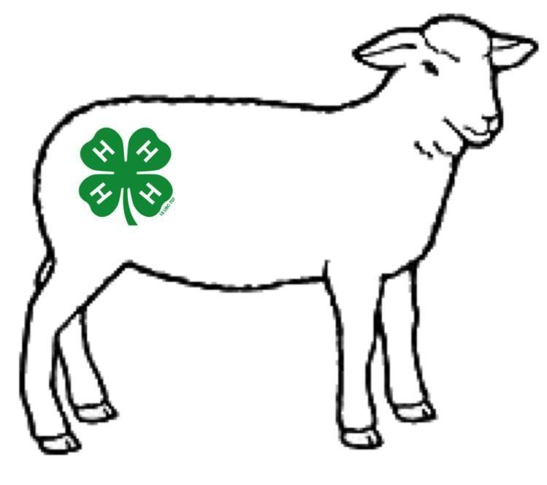
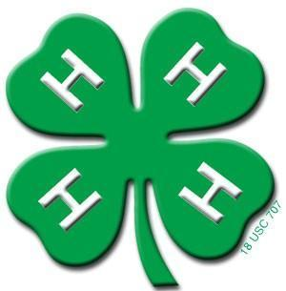
Regional 4-H Youth
Lamb Show
Coordinator: Shea Ann DeJarnette
(910) 671-3276
Saturday, October 5, 2024 11:00 AM Coordinated by North Carolina Cooperative Extension,
Robeson County Center
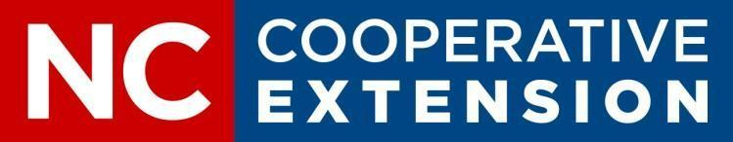

- Limited to youth who pre-register with the Robeson County Center of North Carolina Cooperative Extension.
- Animals must be shown as individuals and each participant limited to one per class.
- Animals will be divided into classes as evenly as possible based on the number of animals and weights.
- Animals will be weighed and participants will receive a show number between 8 am and 10:30 am on Saturday, October 5, 2024. A valid health certificate must also be presented at this time unless a vet tech will be present.
- Lambs may be sold during the fair. Exhibitors receive all money directly from the buyer. There will not be an organized animal project sale.

∙ No unworthy animal will be awarded a premium. Worthiness will be determined by the judge or judges of that category.
Cloverbud Division (ages 5-7) is noncompetitive. Each participant: Trophy & $10.

Showmanship | 1st | 2nd | 3rd | 4th and below
Juniors  (ages 8-10) | $45 | $35 | $25 | $15
Intermediate  (Ages 11-13) | $45 | $35 | $25 | $15
Senior  (Ages 14-18) | $45 | $35 | $25 | $15

Market Show | 1st | 2nd | 3rd | 4th and below
Light Weight | $45 | $35 | $25 | $15
Middle Weight | $45 | $35 | $25 | $15
Heavy Weight | $45 | $35 | $25 | $15

Grand Champion $75 and Trophy Reserve Champion $65 and Trophy

