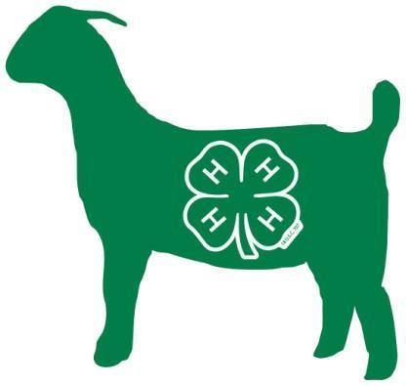
Adult/Youth Breeding Meat Goat Show
Coordinator: Shea Ann DeJarnette &
Taylor Chavis
(910) 671-3276
Saturday, September 28, 2024 6:00 p.m. Coordinated by
North Carolina Cooperative Extension,
Robeson County Center

-Goats must be health certified disease–free.
-Goats must be halter, hand, or collar broken to lead in a show ring.
-Registration must be submitted for each showman by September 20. No additions or substitutions will be allowed on the day of the show.

Doe Shows
Percentage Boer Full Blood Boer
Does born after 6/30/24 Does born after 6/30/24
Does born after 4/1/24-6/30/24 Does born after 4/1/24-6/30/24
Does born after 1/1/24-3/31/24 Does born after 1/1/24-3/31/24
Does born after 10/1/23-12/31/23 Does born after 10/1/23-12/31/23
Does born after 4/1/23-9/30/23 Does born after 4/1/23-9/30/23
Does born after 9/1/22-3/31/23 Does born after 9/1/22-3/31/23
Does born after 8/1/21-8/31/22 Does born after 8/1/21-8/31/22
Does born before 8/1/21 Does born after 8/1/21

Grand Champion Reserve Champion
% Doe Trophy and $75 % Doe Trophy and $65
FB Doe Trophy and $75 FB Doe Trophy and $65

Percentage Boer Full Blood Boer
Buck born after 6/30/24 Buck born after 6/30/24
Buck born after 4/1/24-6/30/24 Buck Born after 4/1/24-6/30/24
Buck born after 1/1/24-3/31/24 Buck born after 1/1/24-3/31/24
Buck born after 10/1/23-12/31/23 Buck born after 10/1/23-12/31/23
Buck born after 4/1/23-9/30/23 Buck born after 4/1/23-3/31/23
Buck born after 9/1/22-3/31/23 Buck born after 9/1/22-3/31/23
Buck born after 8/1/21-8/31/22 Buck born after 8/1/21-8/31/22
Buck born before 8/1/21 Buck born before 8/1/21

Grand Champion Reserve Champion
% Buck Trophy and $75 % Buck Trophy and $65
FB Buck Trophy and $75 FB Buck Trophy and $65

Class Placing
1st $45
2nd $35
3rd $25
4th and Below $15

